Android Car

Software Requirements Specification

Version 1.0


Submitted By:

Saddam Hussain (2011-SE-29)
Junaid Ahmad Butt (2011-SE-22)
Haroon-ur-Rashid (2011-SE-41)

Submitted To: Dr. Saeed Arif Shah
Revision History

Date | Version | Description | Author
(dd/mm/yyyy)
19/02/2015 | 1.0 | Introduction of the project | 2011-SE-22  2011-SE-29  2011-SE-41

Table of Contents

- Scope (of the project)

- Functional Requirements Non Functional requirements

- Use Case Diagram

- Usage Scenarios
SRS Document

Scope of Project:

Overview:
Previous mobile car used Radio Frequency (RF) that had problem on transmission frequency, such as low data rate and the frequency sometimes can be shared to other frequency devices.
Usually Toy Car is controlled through a remote using an RF link which is subject to attenuation, noise and has a very limited range as well.

Scope:
This project is to develop a remote control car using Bluetooth/Wi-Fi communication and android devices that will enable control via Smartphone. The Android Car has a limited control and range which is forward, backward, left and right. The speed and direction is not fixed and not potentiometer. This Android Car is high-end car which use to give precise speed and direction control. This project is developing a smart-phone by using Java language. Camera result will be effected in dark.
This project features an Android Car that uses Wi-Fi for its control signals through TCP/IP protocol, which has flow control. This enables uninterrupted and reliable transmission of control signal to the Android Car. Wi-Fi support high data rates which enables good quality for transmission from the Android Car to the smart-phone.
This Android Car is applicable to multiple scenarios including military missions, police surveillance and search and rescue activities.
It is applicable in areas like blocked tunnels, pipe lines and enemy zones which are not reachable due to high risk level, blockage or because of our physical limitations. Also monitor that area with the help of camera on car.
The toy car commonly used to defuse a bomb, enter into rubble could save a humans life which is more important compared to a mere job.

Functional Requirements:

Functional requirements are necessary for developing systems. These requirements state what the system should be able to accomplish or what the system should do.

- Controlling:
It is a Bluetooth/Wi-Fi powered to control car and camera. The Bluetooth/Wi-Fi can be controlled directly from your Smartphone application. The Bluetooth/Wi-Fi works as a regular RC Toy with left/right and forward/backward directions. User can use the camera to simply view real time images, and shoot pictures or videos. To shoot a picture, just press the photo camera icon. To SHOOT a video, just press the video camera icon.
Following steps will be performing while controlling the car:

- Login:
User will login using his username and password.
- Establishing Link:
After login, connection between application and car will be established.
- Response:
After connection is established, user will be able to control car and will also be able to take pictures and videos from camera.
- Logout:
After driving user will logout from the application.

Non Functional Requirements:

Non-functional requirements are those, which specify criteria that can be used to judge the operation of a system, rather than specific behaviors.

- Usability:

Our system will provide user friendly interface that, it will not take much time to interact effectively with interface. Single click is required to control car.

- Learnability:
Our Application will be easy to learn as it will have a user guide.

- Security:
The main security concern is for users account hence proper login mechanism is provided to the user. Only authorized users will be able to use this application.

- Reliability:
The application will be reliable to use, if user has login and Bluetooth/Wi-Fi is on, the user will be able to control his/her car.

Use Case Diagram:

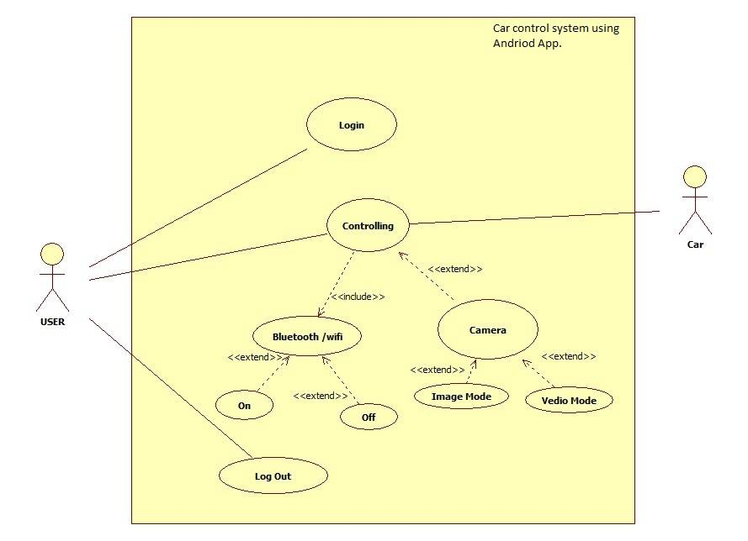

Usage Scenarios:

- “Login” Use Case:

Use Case Title | Login
Abbreviated Title
Use Case Id | UC001
Actors | User
Description: User can login by entering his/her id and password.
Pre Conditions: There must be record of user in the database.
Task Sequence |  | Exceptions
- User enters his/her id and password

- After entering correct id and password user presses Login button to access his account

Post Conditions: User is logged in successfully.
Unresolved issues: None
Modification history: 19/02/2015
Author: 2011-SE-22 , 2011-SE-29 & 2011-SE-41

2. “Controlling” Use Case:

Use Case Title | Controlling
Abbreviated Title
Use Case Id | UC002
Actors | User
Description: Bluetooth/ Wi-Fi technology is being used to control your car and camera. It has effective range (mostly 10 meters in mobile phone/Wi-Fi range).
Pre Conditions: User has to login and Bluetooth/ Wi-Fi should be turned on.
Task Sequence |  | Exceptions
1. Turn on Bluetooth/Wi-Fi if not yet.  2. Select the direction to be drive.  3. Turn on your camera and select camera mode.  4. Move anywhere and take targeted pictures and videos.  6. Store captured pictures and videos on user app.  7. Turn off Bluetooth/ Wi-Fi. |  | - Bluetooth/ Wi-Fi turned off.  - Direction is not selected.
Post Conditions: Controlling is successful .Pictures and videos captured from car camera are successfully store in application.
Unresolved issues: None
Author: 2011-SE-22 , 2011-SE-29 & 2011-SE-41

